Tom Skelley - Curriculum Vitae

SC cleared DevSecOps consultant with large scale Internet and infrastructure experience

Name | Thomas Adrian Skelley
Phone | +44 (0) 7812 131326
Email | tom@tasconsulting.co.uk
LinkedIn | http://www.linkedin.com/in/tskelley

Professional Certifications:
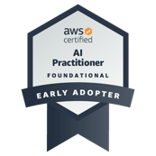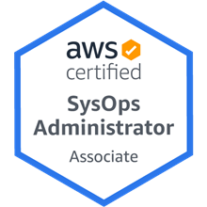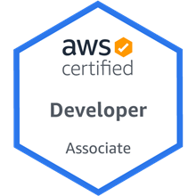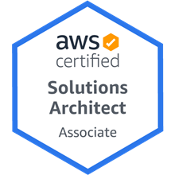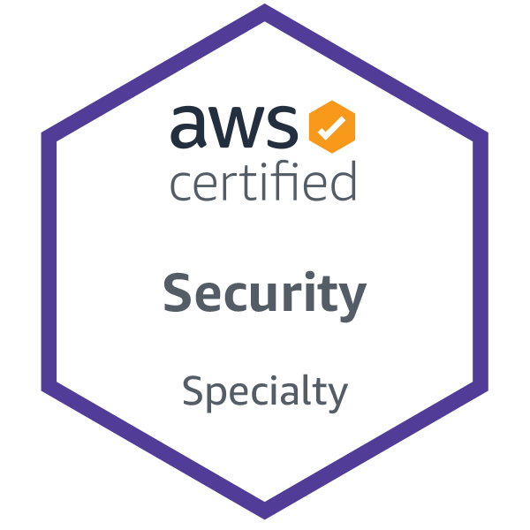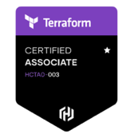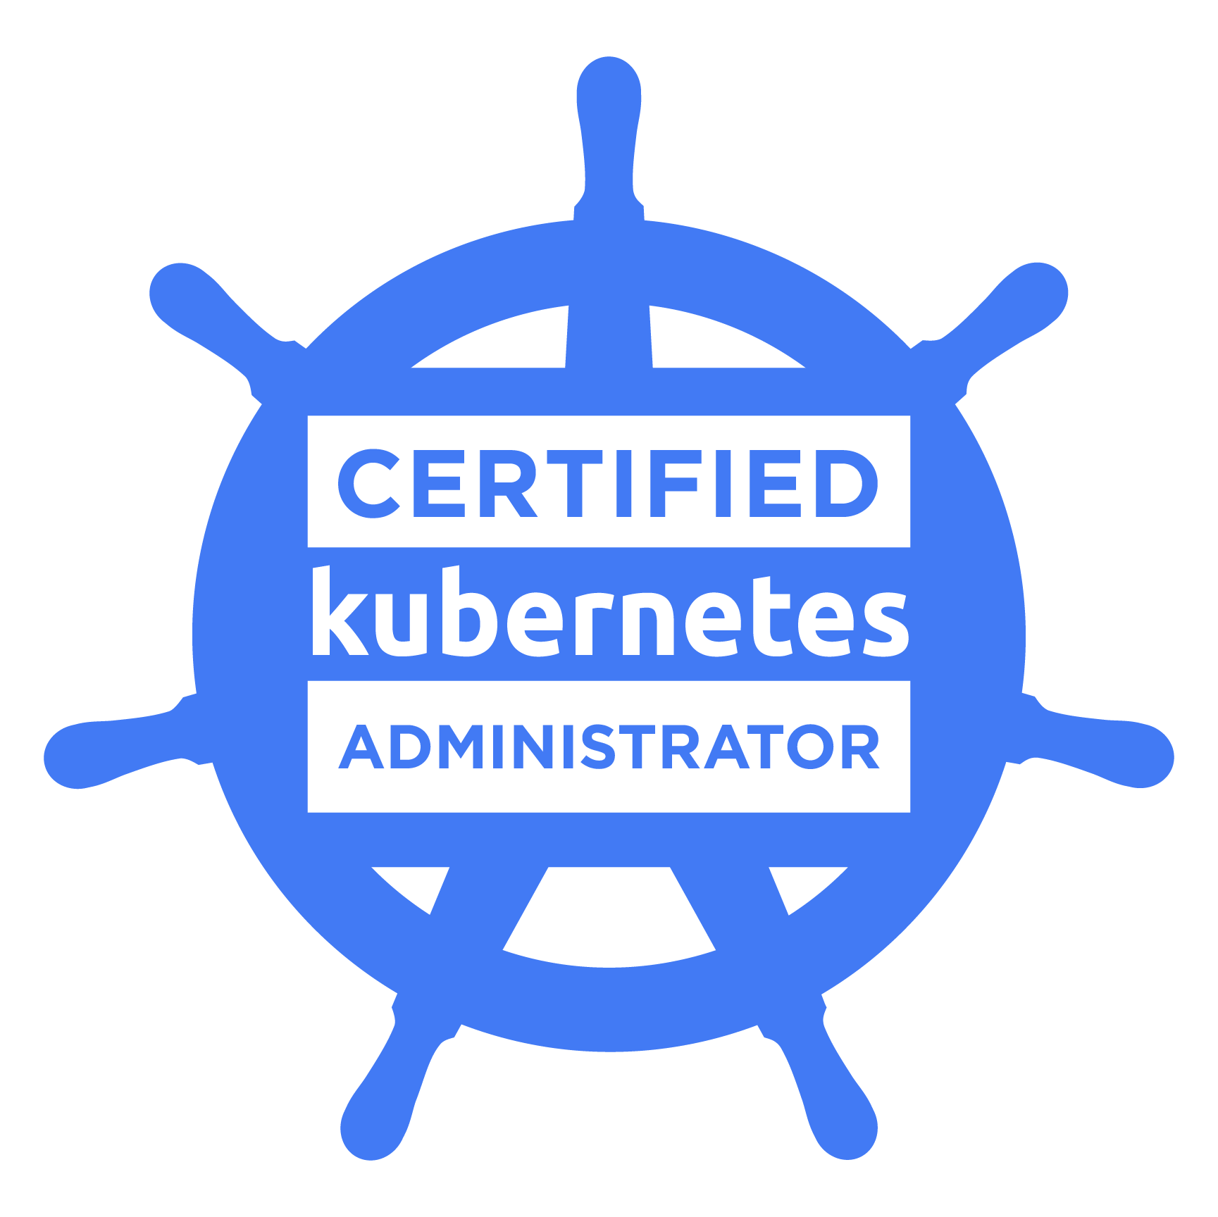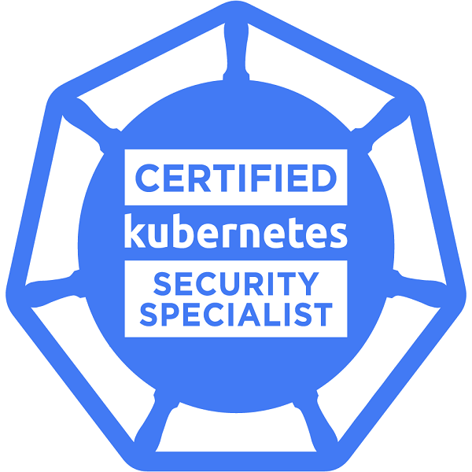

DevOps / Cloud tools:
- AWS, Azure, GCP
- Kubernetes, Helm, Docker
- ElasticSearch, Fluentd, Prometheus, Grafana
- Jenkins, Github Actions, Gitlab Actions, Concourse, Travis
- Bash, ZSH, PERL, Powershell, Python
- Chef, Puppet, Ansible
- VMWare ESXi, vSphere, HyperV, KVM, Xen Enterprise

Operating Systems:
- Linux (Red Hat Enterprise, Centos, Amazon Linux, Ubuntu, FreeBSD, others)
- Windows (3.1, 95, 98, XP, NT, 7, 8, 10, 2003, 2008, 2012, 2016, 2019, 2022)
- AIX
- Solaris

Hardware:
- NetApp Filers, Sun/Oracle SAN, IBM SAN, Cisco switches (IOS/TCPIP), Cisco ASA firewalls, Bluecoat Proxy, IBM P-series, Sun SPARC, Brocade Fibre Switches, Infoblox

Scripting:
- Python, Shell scripting (ksh, bash), Puppet, Chef, Ansible, Powershell, Groovy, Terraform, PERL

Databases:
- RDS, Aurora, MySQL, MariaDB, Postgres, DynamoDB, Oracle

Other:
- Kubernetes Certified Administrator  - Kubernetes Certified Security Specialist  - AWS Certified Solutions Architect  - AWS Certified Developer  - AWS Certified SysOps Administrator  - AWS Certified Security Specialty  - AWS Certiied AI Practitioner | - Hashicorp Certified Terraform Associate  - Customer management  - Vendor management  - Infrastructure design  - Security design  - Familiarity with world class data centre standards  - SC level government security clearance

Work History
October 2023 to date – Department of Work and Pensions
Position: Senior DevSecOps Consultant
Providing DevOps and operational consultancy for the team managing DWP’s Retirement, Bereavement and Care platform.

- Acted as primary infrastructure consultant and platform focal point for Carer’s Allowance and Support platform.
- Acted as primary infrastructure consultant for external penetration test team.
- Lead for migration from RHEL 7 to RHEL 8 across whole estate.
- Maintaining and supporting infrastructure as code for a very large and complex environment.
- Developed an automated AWS docker platform for developers to simulate full stack deployments.
- Developer support.
- Operational support across all 25 deployed production applications.

Skill set used in this contract:

Terraform, Puppet, Ansible, AWS IAM, AWS ECS, AWS EC2, Jenkins, Gitlab Actions, RedHat Enterprise Linux, Packer, Docker, AWS R53.

July 2022 to October 2023 - Adaptive Consulting - Contract
Position: SRE
Providing DevOps consultancy for one of Adaptive’s FinTech clients, ADSS, on a low latency stock, forex and cryptocurrency trading platform. I was specifically responsible for:

- Development and maintenance of a very complex Terraform code base incorporating multiple states, accounts, and custom modules
- Development and maintenance of Jenkins pipelines
- AWS consultancy
- Security consultancy
- Coordinating production software releases with partners and customer staff

Skill set used in this contract:
AWS Lambda, AWS IAM, AWS Cognito, AWS EKS, AWS EC2, Jenkins, AWS CloudFront, AWS S3, Terraform, Git, Docker, Packer, Amazon Linux

February 2022 to July 2022 – WeShape/Thoughtworks - Contract
Position: DevOps Consultant
Providing DevOps consultancy and systems design for one of Thoughtworks’ Government clients, the UK Security Vetting agency, on a secure portal.

Skill set used in this contract:
AWS Lambda, AWS IAM, AWS Cognito, AWS CloudFront, AWS S3, Github Actions, Terraform, Git

November 2021 to February 2022 – Contino - Contract
Position: Principal Consultant
Responsible for design and deployment of AWS landing zones into two of Contino’s clients, a bank and an insurance company.

Skill set used in this contract:
AWS, Kubernetes, Terraform, AWS CodeCommit, AWS CodePipeline, Packer, Powershell, Windows 2019

June 2020 to November 2021 – Ministry of Justice - Contract
Position: DevOps and Digital Transformation Consultant
Responsible for supporting, maintaining and enhancing the MoJ’s big data analytical platform. The legacy version of the platform is based around Kubernetes, hosted in AWS, and built using Terraform and KOPS. CI/CD is managed using Concourse, and applications, including Jupyter, and RStudio are deployed using Helm. My current role involves the migration of the platform to EKS and the CI/CD pipeline from Concourse to GitHub actions runners.
In addition to work on the main platform I was responsible for:
- Upgrading the ElasticStack instance from 6.3 to 7.8, and streamlining to implementing cost savings of more than $10k per month.
- Primary contact with the security audit/penetration team,
- Providing consultancy on connecting the analytical platform to wider government systems for data sharing.
- Proof of concept work into other areas including AWS Transcribe.
Skill set used in this contract:
AWS, Kubernetes, Helm, Terraform, Concourse, Docker, Git, ElasticSearch, FluentD, FluentBit, FileBeats, KOPS, EKS, Azure, GitOps, GitHub Actions

July 2018 to May 2020 – ITV – Contract
Position: DevOps and Digital Transformation Consultant
Responsible for supporting, maintaining and enhancing the migration of ITV’s Talent (front of camera) Payment platform (initially written in the 1980s and running on a virtualized mainframe) to JAVA microservices running in AWS, consisting of eight development environments and one production environment.
I was also responsible for managing the platform on a day to day basis, including managing the monitoring (sensu/uchiwa) and logging (ELK).
The platform was built out using Terraform and Puppet, using Jenkins for CI/CD.
I also managed the migration of the application from Java 8 to Java 11, running both concurrently for testing and tooling.
Skill set used in this contract:
AWS, Terraform, Jenkins, Docker, Puppet, Git, Ubuntu, Redhat, Alpine Linux, Kubernetes

October 2017 to July 2018 – Government Digital Services – Contract
Position: DevOps and Digital Transformation Consultant
Development and deployment of a pan-European identity management system, including three distinct pieces of work:
- The evaluation and prototype implementation of a new continuous integration pipeline, initially using Travis (Enterprise and hosted), and then production implementation of a Jenkins solution (based in AWS).
- Migration of various environments from within a hosted VMWare environment into AWS, utilizing Puppet, Ansible, and Terraform.
- The deployment of a foreign country’s middleware product into a green field AWS environment.

Skill set used in this contract:
AWS, Terraform, Jenkins, Docker, Puppet, Ansible, Travis, VMWare, Git, Ubuntu, Amazon Linux

April 2017 to October 2017 – Consultancy: FrontFive – Client: InsightSoftware – Contract
Position: Senior DevOps Consultant
Responsible for the design and implementation of a CI/CD pipeline using Jenkins, Terraform and Chef to achieve both rapid and reproducible client virtual server builds for AWS and VMWare, and infrastructure and deployment of applications to them.
I was also responsible for reverse engineering existing prebuilt build and test server VMware VMs in order to reproduce them in AWS. These build servers were based on Windows 2012, Centos and Ubuntu.
Skill set used in this contract:
TeamCity, Windows, Ubuntu, Docker, Rancher, Chef, Ansible, Powershell, AWS, S3, Terraform, Jenkins, VMWare ESX/vCenter.

January 2017 to April 2017 – WTG / Civica – Contract
Position: Senior Systems Engineer
Worked to scope a replacement for a bespoke secure mail system, which I helped set up in during my first contract in 2005.

The project involved evaluating a number of potential platforms, and migration strategies and was complicated by the fact that the solution operated on a completely air gapped private network, interacting with a number of other discrete systems which were also close to being end of lifed.

Skill set used in this contract:
Customer management, Vendor Management, Ansible, various MTA and IMAP products, RedHat Enterprise Linux, OpenLDAP, SunOne LDAP.

January 2016 to Feb 2018 – Shepherd Networks – Contract
Position: DevOps / Systems Consultant
In addition to my full-time roles, I was involved with a startup company, Shepherd Networks, providing systems architecture and implementation support for their infrastructure (predominantly hosted inside Azure). I was responsible for all design and decisions related to infrastructure, working directly with the CTO.
As Shepherd do not have the workload or requirement for a full-time system administrator, I automated most of the day to day tasks using Ansible, and wrote custom, self healing checks for Nagios.
Skill set used in this contract:

RedHat Enterprise Linux, Ubuntu, Ansible, Azure, PERL, Shell, Nagios, Apache, Docker

Previous work history (more information available on request):

Date | Company | Role
Sept 2016 – Dec 2016 | eSure Insurance (contract) | DevOps Consultant
Nov 2015- Aug 2016 | IBM (contract) | Technical Architect / Consultant
Jun 2015 - Nov 2015 | CGI (contract) | Infrastructure Technical Architect / Consultant
Jan 2014 - May 2015 | IBM (contract) | Technical Architect
Dec 2012 – Jan 2014 | BT (contract) | Technical Architect
Feb 2011 – Dec 2012  Jan 2010 – Feb 2011  Sep 2009 – Jan 2010 | IBM (contract)  Betfair (contract)  Serco (contract) | Technical Architect  DevOps and Data Centre Migration Consultant  IBM pSeries Architect
Oct 2007 – Sep 2009 | Logica CMG (contract) | Infrastructure Architect / Environment Manager
Jan 2007 - Oct 2007 | Fujitsu (contract) | Infrastructure Architect
Jul 2006 – Jan 2007 | IBM (contract) | Developer / Systems Admin
Sep 2005 – Jul 2006 | Cable & Wireless (contract) | LDAP / UNIX Consultant
Oct 2001 – Mar 2004 | Yahoo! | European Systems Admin Manager
Jan 2001 – Sep 2001 | Airflash Wireless | Operations and Support Engineer
Jan 1999 – Jan 2001 | Netscape Communications | Northern European Technical Support Manager
Aug 1997 – Jan 1999 | IBM | Value Added Network Specialist

Education History
BSc Hons. Computer Science and Software Engineering, University of Birmingham (2i)

Travel
After working for Yahoo for two and a half years, I decided that I would like to take a career break. I chose to travel, experiencing a wide variety of cultures and places. Between March 2004 and July 2005 I visited much of the world, including Africa, Asia (including China), Australia, New Zealand, South and North America.

Triathlon
I am a keen triathlete, and have competed at most distances, including the iron distance ‘Outlaw’ race in Nottingham, and the Ironman European (Frankfurt) and Asia Pacific (Melbourne) championships. I have recently completed the Race to the Stones 100k ultramarathon.

